|  |  |  |  |
| --- | --- | --- | --- |
| **Course Name:** | **Digital Design Laboratory** | **Semester:** | **III** |
| **Date of Performance:** | **/ /** | **Batch No:** | **A2** |
| **Faculty Name:** |  | **Roll No:** | **16010123032** |
| **Faculty Sign & Date:** |  | **Grade/Marks:** | **/25** |

Experiment No: 4

**Title: 4-bit magnitude comparator**

To design and implement 1-bit comparator using logic gates and verify 4-bit magnitude comparator using IC 7485

**Aim and Objective of the Experiment:**

**CO2**: Use different minimization techniques and solve combinational circuits.

**COs to be achieved:**

Trainer kits

**Tools used:**

**Comparator:** The comparison of two numbers is an operator that determines one number is greater than, less than (or) equal to the other number. A magnitude comparator is a combinational circuit that compares two numbers A and B and determines their relative magnitude. The outcome of the comparator is specified by three binary variables that indicate whether A>B, A=B (or) A<B.

**Theory:**

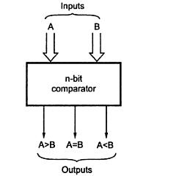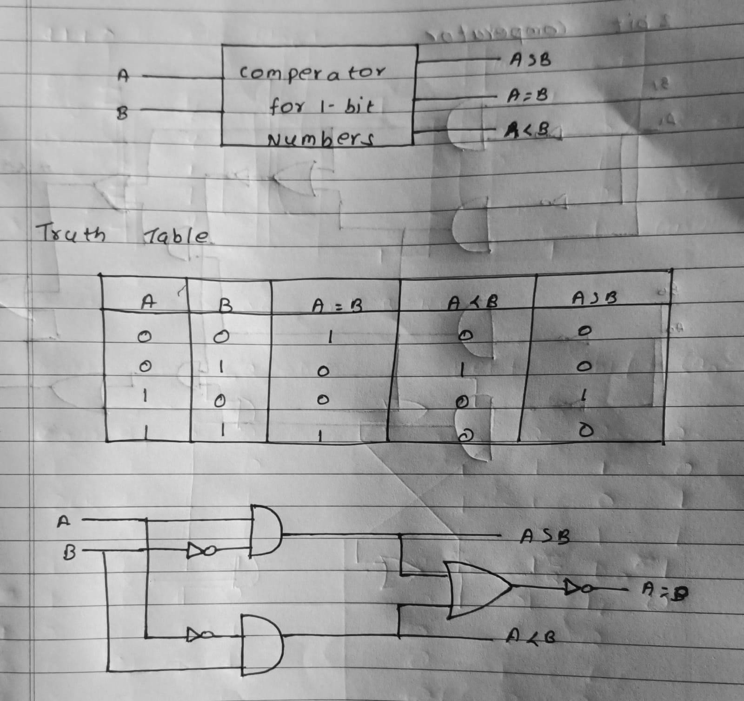

1-bit Comparator Implementation Details: Truth Table

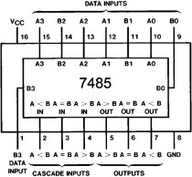

**Four Bit Magnitude Comparator Implementation Details Pin Diagram of IC 7485**

**Logic Diagram of IC 7485**

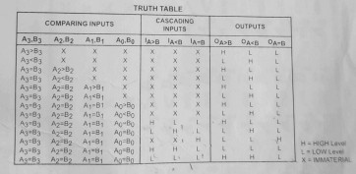

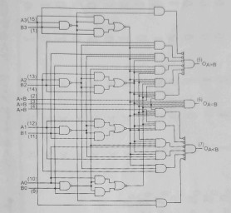

**Comparing Table**

**Procedure:**

1. Locate the IC 7485 on the trainer kit.
2. Connect 1st input no. to A3-A0 input slot and 2nd to B3-B0.

**Implementation Details**

|  |
| --- |
| 1. Connect the output YA>B , YA<B and YA=B to the output indicators. 2. Switch ON the power supply and monitor the output for various input combinations. |
| **Post Lab Subjective/Objective type Questions:** |
| 1. Design 2-bit magnitude comparator.      1. How can we implement 5-bit magnitude comparator using IC 7485.   To implement a 5-bit magnitude comparator using IC 7485:   1. **Use Two ICs:** IC 7485 is a 4-bit comparator; use two ICs. 2. **Connect First IC:** Inputs for the 4 MSBs of the numbers; get the comparison result for these bits. 3. **Connect Second IC:** Input the LSBs; combine with the results from the first IC. 4.   **Combine Outputs:** Use the outputs from both ICs to determine if the numbers are equal, greater than, or less than each other. |

Thus, in this experiment, we learned about binary comparators and how to implement them using IC7485.

**Conclusion:**

Signature of faculty in-charge with Date: